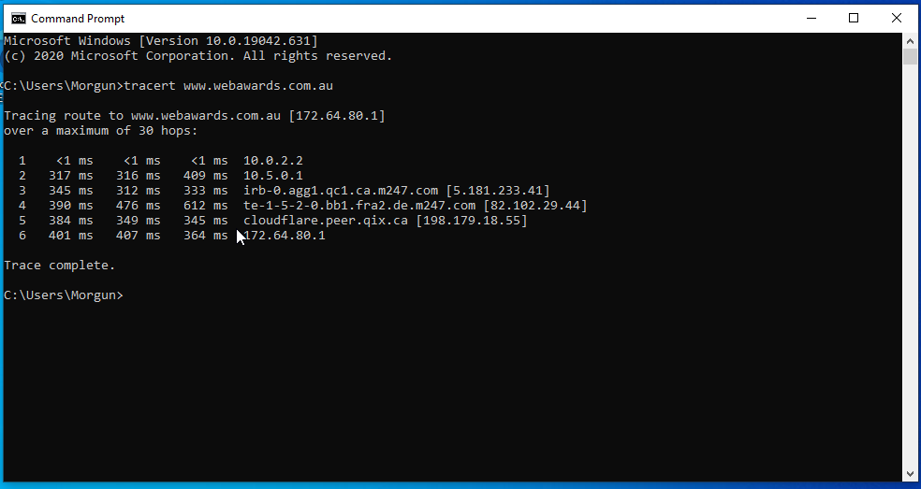

|  |  |  |  |
| --- | --- | --- | --- |
| **HOP Count** | **IP Address** | **Organization (IP Owner)** | **Location (US state)/Country** |
| 1 | 10.0.2.2 | - | - |
| 2 | 10.5.0.1 | - | - |
| 3 | 5.181.233.41 | m247 ltd quebec infrastructure | Canada |
| 4 | 82.102.29.44 | m247 ltd | United States |
| 5 | 198.179.18.55 | montreal internet exchange inc. | Canada |
| 6 | 172.64.80.1 | cloudflare inc | United States |